**Chapter - 1**

**Introduction to Animation**

**Animation**

Animation is the process of designing, drawing, making layouts and preparation of photographic which are integrated in the multimedia and gaming products. Animation involves the exploitation and management of still images to generate the illusion of movement. A person who creates animations is called animator. He/she use various computer technologies to capture the still images and then to animate these in desired sequence.

3D Animation

Traditional Animation

Stop Motion

**Types of Animation**

Motion Graphics

2D Animation

Figure1.1: Types of Animation

1. **Traditional Animation**

This is one of the oldest forms of animation in film. It’s sometimes called Cel animation. As mentioned above, in traditional animation objects are drawn on celluloid transparent paper. In order to create the animation sequence, the animator must draw every frame. It’s the same mechanism as a flipbook just on a grander scale. Traditional is most often 2D animation. Aladdin, The Lion King, and other earlier cartoons are the best examples of this. In the earlier years of traditional animation, the animator would draw on a table that had a light inside of it, so the creator could see his or her previous animation. While traditional animation is not nearly as prevalent today, drawings are generally done on tablets. And manual colouring hasn’t been used by Disney since The Little Mermaid in 1989.

In the traditional animation process, animators will begin by drawing sequences of animation on sheets of transparent paper perforated to fit the peg bars in their desks, often using coloured pencils, one picture or "frame" at a time. A peg bar is an animation tool used in traditional (cel) animation to keep the drawings in place. The pins in the peg bar match the holes in the paper. It is attached to the animation desk or light table, depending on which is being used. A key animator or lead animator will draw the key drawings in a scene, using the character layouts as a guide. The key animator draws enough of the frames to get across the major poses within a character performance; in a sequence of a character jumping across a gap, the key animator may draw a frame of the character as he is about to leap, two or more frames as the character is flying through the air and the frame for the character landing on the other side of the gap.

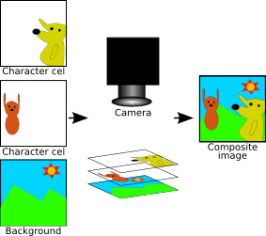

Figure1.2: This image shows how two transparent cels, each with a different character drawn on them, and an opaque background are photographed together to form the composite image.

Timing is important for the animators drawing these frames; each frame must match exactly what is going on in the soundtrack at the moment the frame will appear, or else the discrepancy between sound and visual will be distracting to the audience. The cel is an important innovation to traditional animation, as it allows some parts of each frame to be repeated from frame to frame, thus saving labour. A simple example would be a scene with two characters on screen, one of which is talking and the other standing silently. Since the latter character is not moving, it can be displayed in this scene using only one drawing, on one cel, while multiple drawings on multiple cels are used to animate the speaking character.

1. **2D Animation**

2D animation is the art of creating movement in a two-dimensional space. This includes characters, creatures, FX and backgrounds. The illusion of movement is created when individual drawings are sequenced together over time. One second of time is usually divided into 24 frames. Depending on the style of animation there can be as many as 24 unique drawings in one second of animation (24fps) or as little as two. Conventionally animation is done on "2s" meaning there is a drawing every 2 frames (12fps). This allows artists to save on production time/costs and gives 2D animation its unique look

2D is a popular and diverse medium that's making a massive comeback. It can be seen prevalently in TV shows, video games, feature films, advertisements, mobile apps and on websites. Popular modern examples of 2D include TV shows Rick and Morty and F is for Family. Social media platforms like Snapchat are launching 2D animated series with snappy 1-3 minute episodes. And there's even been a recent surge in 2D platform video games such as Cuphead.

“Animation is used for everything online (advertising, entertainment), even if you don't realize it initially,” says Scott Claus, 2D Animation Mentor at CG Spectrum. “The medium is evolving quickly. Television animation has taken off, and streaming services are constantly looking for new content.”

Demand for 2D animators who can create entertaining and engaging content has grown significantly in the last decade. There’s a need for skilled and enthusiastic artists who love motion graphics and are adept at creating original and appealing content.

1. **3D Animation**

3D animation or computer animation is the most common type. But just because computers have stepped in instead of actual drawings, it’s not necessarily easier. The computer is just another tool, and 3D animation is still a long, intense process. In 3D animation, the animator uses a program to move the character’s body parts around. They set their digital frames when all of the parts of the character are in the right position. They do this for each frame, and the computer calculates the motion from each frame. Animators adjust and tweak the curvatures and movements their characters make throughout. 3D animation is also unique in that, unlike 2D, or other traditional methods, the character’s entire body is always visible. If a character turns to the side, the animator only needs to draw the side profile in 2D animation, but in 3D, the entire body still needs to be visible. So again, even though computers are being used, with new technology comes with way more considerations.

1. **Motion Graphics**

Motion Graphics are pieces are digital graphics that create the illusion of motion usually for ads, title sequences in films, but ultimately exist to communicate something to the viewer. They’re often combined with sound for multimedia projects. They’re a type of animation used mostly in business, usually with text as a main player.

Motion graphics are pieces of animation or digital footage which create the illusion of motion or rotation, and are usually combined with audio for use in multimedia projects. Motion graphics are usually displayed via electronic media technology, but may also be displayed via manual powered technology. Motion graphics extend beyond the most commonly used methods of frame-by-frame footage and animation. Motion graphics can be distinguished from typical animation in that they are not strictly character driven or story based and often represent animated abstract shapes and forms such as logos or logo elements. Motion graphics continue to evolve as an art form with the incorporation of sweeping camera paths and 3D elements. Maxon's CINEMA 4D, plugins such as MoGraph and Adobe After Effects. Despite their relative complexity, Autodesk's Maya and 3D Studio Max are widely used for the animation and design of motion graphics, as is Maya and 3D Studio which uses a node-based particle system generator similar to Cinema 4D's Thinking Particles plugin. There are also some other packages in Open Source panorama, which are gaining more features and adepts in order to use in a motion graphics workflow, while Blender integrates several of the functions of its commercial counterparts.

Many motion graphics animators learn several 3D graphics packages for use according to each program's strengths. Although many trends in motion graphics tend to be based on a specific software's capabilities, the software is only a tool the broadcast designer uses while bringing the vision to life.

1. **Stop Motion**

Stop motion animation encompasses Claymation, pixelation, object-motion, cut-out animation, and more. But the basic mechanics are similar to traditional animation or a flipbook. However, instead of drawings, stop motion adjusts physical objects in each frame. If moved in small increments, captured one frame at a time, the illusion of motion is produced. Whether puppets, clay, or even real people, these manual adjustments can make it a long, arduous process.

Stop motion is an animated filmmaking technique in which objects are physically manipulated in small increments between individually photographed frames so that they will appear to exhibit independent motion or change when the series of frames is played back. Any kind of object can thus be animated, but puppets with movable joints (puppet animation) or plasticine figures (clay animation or Claymation) are most commonly used. Puppets, models or clay figures built around an armature are used in model animation. Stop motion with live actors is often referred to as pixilation. Stop motion of flat materials such as paper, fabrics or photographs is usually called cut-out animation.

The term "stop motion," relating to the animation technique, is often spelled with a hyphen as "stop-motion." Both orthographical variants, with and without the hyphen, are correct, but the hyphenated one has a second meaning that is unrelated to animation or cinema: "a device for automatically stopping a machine or engine when something has gone wrong" .Stop motion should not be confused with the time-lapse technique in which still photographs of a live scene are taken at regular intervals and then combined to make a continuous film in which time appears to be moving faster.

**Twelve Basic Principles of Animation**

Twelve basic principles of animation were introduced by the Disney animators Ollie Johnston and Frank Thomas in their 1981 book The Illusion of Life: Disney Animation. The principles are based on the work of Disney animators from the 1930s onwards, in their quest to produce more realistic animations. The main purpose of these principles was to produce an illusion that cartoon characters adhered to the basic laws of physics, but they also dealt with more abstract issues, such as emotional timing and character appeal.

1. **Squash and Stretch**

The purpose of squash and stretch is to give a sense of weight and flexibility to drawn objects. It can be applied to simple objects, like a bouncing ball, or more complex constructions, like the musculature of a human face. Taken to an extreme, a figure stretched or squashed to an exaggerated degree can have a comical effect. In realistic animation, however, the most important aspect of this principle is that an object's volume does not change when squashed or stretched. If the length of a ball is stretched vertically, its width (in three dimensions, also its depth) needs to contract correspondingly horizontally.

Squash and stretch makes an illusion of character's elasticity, volume and flexibility. Squash and stretch is also helpful in facial animation. The extent of squash and stretch depends on scene requirements and animation stylistics. More often squash and stretch is extremely strong in animation films and feeble in feature films when realistic characters are used. Squash and stretch is used in all kinds of character animation from bouncing ball to moving person.



### 2. Anticipation

Anticipation is used to prepare the audience for an action, and to make the action appear more realistic. A dancer jumping off the floor has to bend the knees first; a golfer making a swing has to swing the club back first. The technique can also be used for less physical actions, such as a character looking off-screen to anticipate someone's arrival, or attention focusing on an object that a character is about to pick up.

This motion prepares a viewer for the main action, which the character intends to do. For instance, starting to run, jump or make a dash. To jump up, first you need to squat - this is preparation or anticipation. Comic effect can be achieved without preparation or anticipation after you used it several times. Virtually all real motions to a greater or lesser extent contain preparation or anticipation - a sweeping motion with the bandy before a strike, squat before a jump, swinging your arm back before throwing a stone, etc.

### 3. Staging

This is the most general of principles, it covers so many areas and goes back so far in the theatre. The meaning however is very precise, it is the presentation of any idea so that it is completely and unmistakable clear. An action is staged so that it is understood, a personality so that it is recognizable, an expression so that it can be seen, a mood so that it will affect the audience. Each is communicating to the fullest extent with the viewer’s when it is properly staged.

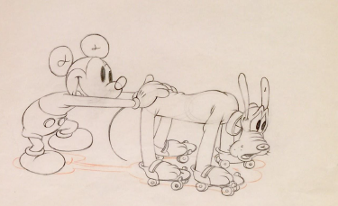

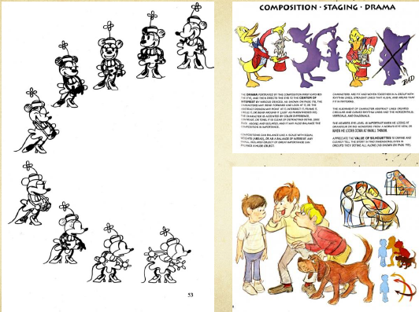

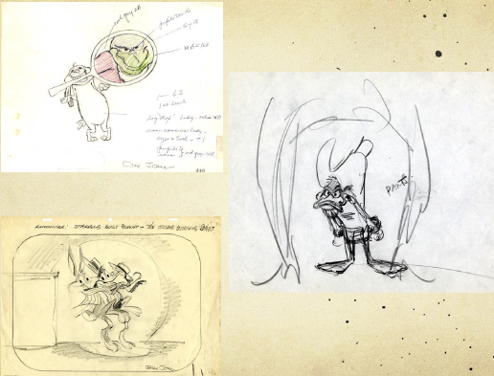

**4. Straight ahead action and pose to pose**

There are two main approaches to animation. The first is Straight Ahead Action, which means literally that you begin with the first drawing and then the second and so forth. Pose to Pose animation is where the animator will draw out key poses in an animated scene to block out the action, once the key poses are just right the animator will fill in the animation with what are called in-between drawings to polish off feel and timing.

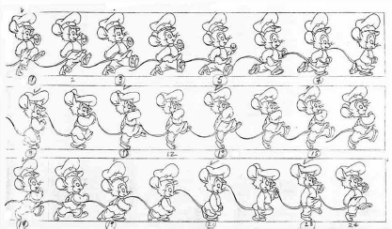

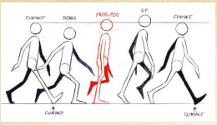

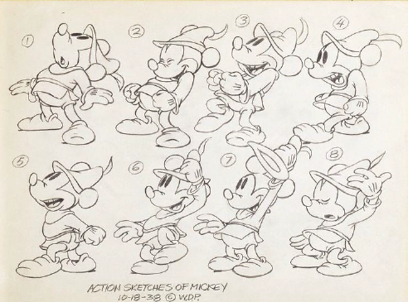

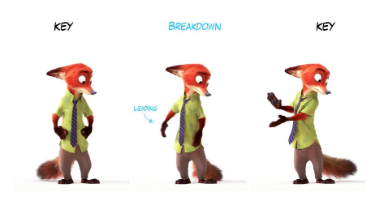

**5. Follow through and overlapping action**

This is the term for animation that is applied to items that are attached to a character that do not move independently. When a character entering a scene reached the spot for his next action, the character often has to come to a sudden stop. This will look stiff and not natural unless items such as clothes, hair, necklaces, tails (with the exception that a tail can also have secondary action), and so on keep moving after the character has stopped and then settle into place.

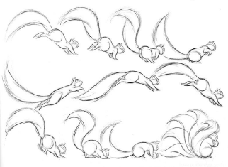

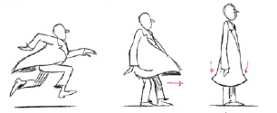

### 6.Slow in and slow out

### The movement of objects in the real world, such as the human body, animals, vehicles, etc. needs time to accelerate and slow down. For this reason, more pictures are drawn near the beginning and end of an action, creating a slow in and slow out effect in order to achieve more realistic movements. This concept emphasizes the object's extreme poses. Inversely, fewer pictures are drawn within the middle of the animation to emphasize faster action. This principle applies to characters moving between two extreme poses, such as sitting down and standing up, but also for inanimate, moving objects.

### 

### 

### 

### 7. Arcs

### Most natural action tends to follow an arched trajectory, and animation should adhere to this principle by following implied "arcs" for greater realism. This technique can be applied to a moving limb by rotating a joint, or a thrown object moving along a parabolic trajectory. The exception is mechanical movement, which typically moves in straight lines.

### As an object's speed or momentum increases, arcs tend to flatten out in moving ahead and broaden in turns. In baseball, a fastball would tend to move in a straighter line than other pitches; while a figure skater moving at top speed would be unable to turn as sharply as a slower skater, and would need to cover more ground to complete the turn.

### An object in motion that moves out of its natural arc for no apparent reason will appear erratic rather than fluid. For example, when animating a pointing finger, the animator should be certain that in all drawings in between the two extreme poses, the fingertip follows a logical arc from one extreme to the next. Traditional animators tend to draw the arc in lightly on the paper for reference, to be erased later.

### Animators use arcs to make sure that the animation of a character for example looks solid and the proportions stay the same, even if squash and stretch is being applied. Arcs can be plotted everywhere a character has a joint and something that moves from that joint, for example a hand would move on an arc that is designated by the wrist and so on. In 3D animation the rotation tool has made this principle clear to use.

### 



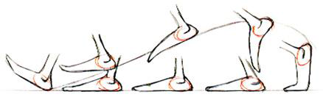



**8. Secondary Action**

This principle deals with actions that happen in addition to the characters primary action. For example if you have a character that is walking down the street, the action of walking would be primary. If that same character raises an arm to wave at someone while they are walking, the arm movement and wave is the secondary action. The secondary action usually works to always support the primary action.

Adding secondary actions to the main action gives a scene more life, and can help to support the main action. A person walking can simultaneously swing their arms or keep them in their pockets, speak or whistle, or express emotions through facial expressions. The important thing about secondary actions is that they emphasize, rather than take attention away from the main action. If the latter is the case, those actions are better left out. For example, during a dramatic movement, facial expressions will often go unnoticed. In these cases, it is better to include them at the beginning and the end of the movement, rather than during.





**9. Timing**

Timing is everything, in an animated film there are 24 frames per second, some animators will shoot on twos meaning that for every 2 frames of film one drawing will be held and therefore for one second the animator would do 12 drawings. Animators play with timing all of the time, sometimes you hold a drawing or image for 3, 4 and 1 frames and so on, until the desired look appears in the playback. Timing also has to do with the spacing of your drawings.

Timing refers to the number of drawings or frames for a given action, which translates to the speed of the action on film. On a purely physical level, correct timing makes objects appear to obey the laws of physics. For instance, an object's weight determines how it reacts to an impetus, like a push; as a lightweight object will react faster than a heavily weighted one. Timing is critical for establishing a character's mood, emotion, and reaction. It can also be a device to communicate aspects of a character's personality.







**10. Exaggeration**

It is an effect especially useful for animation, as animated motions that strive for a perfect imitation of reality can look static and dull. The level of exaggeration depends on whether one seeks realism or a particular style, like a caricature or the style of a specific artist. The classical definition of exaggeration, employed by Disney, was to remain true to reality, just presenting it in a wilder, more extreme form. Other forms of exaggeration can involve the supernatural or surreal, alterations in the physical features of a character; or elements in the storyline itself. It is important to employ a certain level of restraint when using exaggeration. If a scene contains several elements, there should be a balance in how those elements are exaggerated in relation to each other, to avoid confusing or overawing the viewer.

Also known as pushing the pose, exaggeration has to do with taking an action and pushing it to the next level for clarity of story. It is what makes a drawing sometimes look “cartoony” but with great effect will get the action or expression of a character across to the audience with zero confusion to what is going on in the scene.



 



**11. Solid Drawing**

Pertaining to an artist draftsman ship skills, solid drawing has to do with the understanding of drawing. Creating a visual that becomes three dimensional on a two dimensional surface is the main goal of solid drawing. Drawing through the form and thinking about staging for your animation, does the silhouette make sense for the action and then make sure it is believable as a solid object.

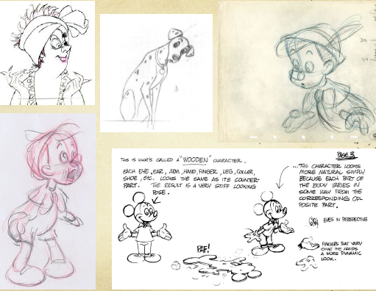

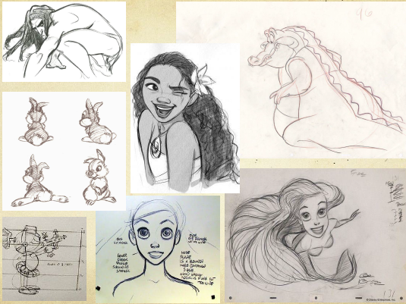

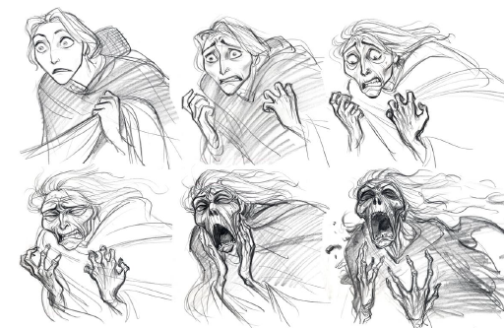

12. Appeal

The last principle is appeal and this is one of the most important principles to learn. To have appeal the image does not always have to be what is considered a traditionally pretty or a beautiful image, villains have an appeal all their own. Basically, appeal is like the hook of a good novel it grabs an audience’s attention so they will stick with the story, appeal in the sense of film uses unique imagery to gain attention and then wow with the actions and good storytelling.

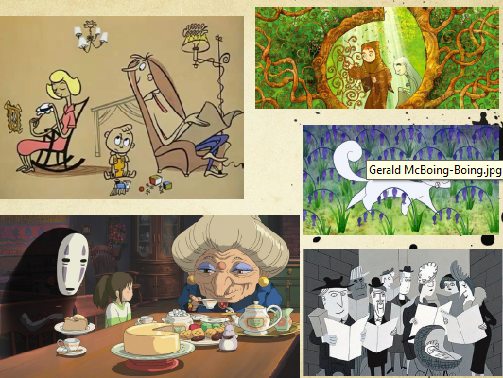

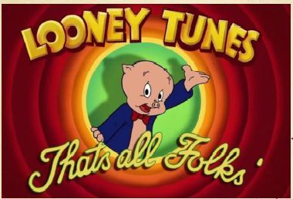

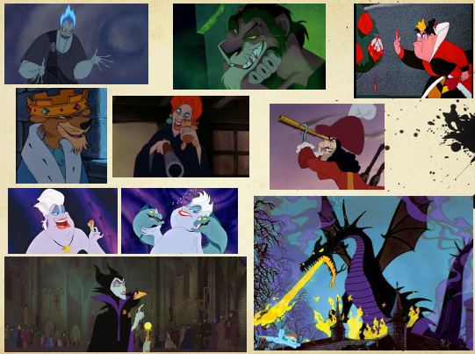

**Chapter - 2**

**Stop Motion Animation**

Stop motion is an animated filmmaking technique in which objects are physically manipulated in small increments between individually photographed frames so that they will appear to exhibit independent motion or change when the series of frames is played back. Any kind of object can thus be animated, but puppets with movable joints (puppet animation) or plasticine figures (clay animation or claymation) are most commonly used. Puppets, models or clay figures built around an armature are used in model animation. Stop motion with live actors is often referred to as pixilation. Stop motion of flat materials such as paper, fabrics or photographs is usually called cutout animation. A small video to show the stop motion: (<https://youtu.be/h8dTBthEEvA>).

<https://play.google.com/store/apps/details?id=com.cateater.stopmotionstudio&hl=en>

This is app link which is used for stop motion animation, **Stop Motion Studio** App. Stop Motion Studio is a powerful, full-featured movie editor with a whole host of features:

* A simplistic, easy-to-use interface
* Overlay mode showing the differences between frames
* Animation guides to position animated objects more easily
* Copy, paste, cut, and insert frames at any position
* Interactive timeline so you never get lost, even if you have hundreds of frames

**For practise purpose: Six situations of stop motion**

1. Car is parked on the left side, it starts slowly, gains speed and hits the wall.
2. Car is parked on the left side, it gains speed and applies brake to stop.
3. Car is coming from outside the scene at constant speed and then applies break to stop.
4. Car is coming from outside the scene at constant speed and hits the wall.
5. Car is parked on the left side, it anticipates towards backside before moving forward then gains speed and hits the wall.
6. Car is parked on the left side, it starts slowly, gains speed, then applies brakes to slow down in the middle of the paper, but again speeds up to hit the wall.

**Chapter - 3**

**Introduction of Adobe Premiere**

**3.1 Installation of Software**